**Fractional Pole**

Fractional zero transfer function is given by $T(s$) = $\frac{1}{s^{α}+a}$…... (4)

Put s = jω, in equation (4) results into $T(jω$) = $\frac{1}{({jω)}^{α}+a}$…… (5)

Magnitude in dB is given by |) | dB = -20log ( $\sqrt{a^{2}+ω^{2α}+2{aω}^{α}\cos{\frac{πα}{2}}}$)

**Calculation procedure**

$({jω)}^{α}$ = $({0+1j)}^{α}$ = ${\text{(cos}\frac{π}{2}+j\text{sin }\frac{π}{2}\text{)} }^{α}ω^{α}$

Applying De Moivre’s theorem in above equation we get

= $\text{(cos}\frac{απ}{2}+j\text{sin }\frac{απ}{2}\text{)}ω^{α}$…… (6)

Put equation (6) in (5) we get

$T(jω$) = $\frac{1}{(cos\frac{απ}{2}+jsin \frac{απ}{2}). ω^{α}+a}$ = $\frac{1}{(ω^{α}.cos\frac{απ}{2}+a)+ jω^{α}sin \frac{απ}{2}.}$

Magnitude, |) | =

= =

Now, Magnitude in dB, |) | dB = -20log ${\text{(}ω^{2α}\text{+ }a^{2}\text{+ }2ω^{α}a\text{cos}\frac{απ}{2}\text{)}}^{\frac{1}{2}}$

In the sum ${(ω}^{2α}\text{+ }a^{2}\text{+ }2ω^{α}a\text{cos}\frac{απ}{2}$), $a^{2}$ dominates at lower frequencies whereas $ω^{2α}$ dominates at higher frequencies.

For approximation we consider $a^{2}$ = $ω^{2α}|_{ω=ω_{cr}}$.We obtain corner frequency, $ω_{cr}$ = ${|a|}^{\frac{1}{α}}$.

Now, following approximation of magnitude is obtained:

1. For ω ≤ , |T(jω) | dB = -20log ${(a^{2})}^{\frac{1}{2}}$ = -20log|a|.
2. For ω >, |T(jω) | dB = -20log ${(ω^{2α})}^{\frac{1}{2}}$ = -20αlog ω.

**Procedure**

* Compute the corner frequency $ω_{cr}$ = ${|a|}^{\frac{1}{α}}$ and locate point A at magnitude -20log|a|.
* Draw a slope 0 dB/decade for ω ≤ $ω_{cr}$ and a line with slope -20α dB/decade for ω> $ω_{cr}.$

**Result:** Taking α = 0.9, a=2 and $ω_{cr}$ = 2.1584.

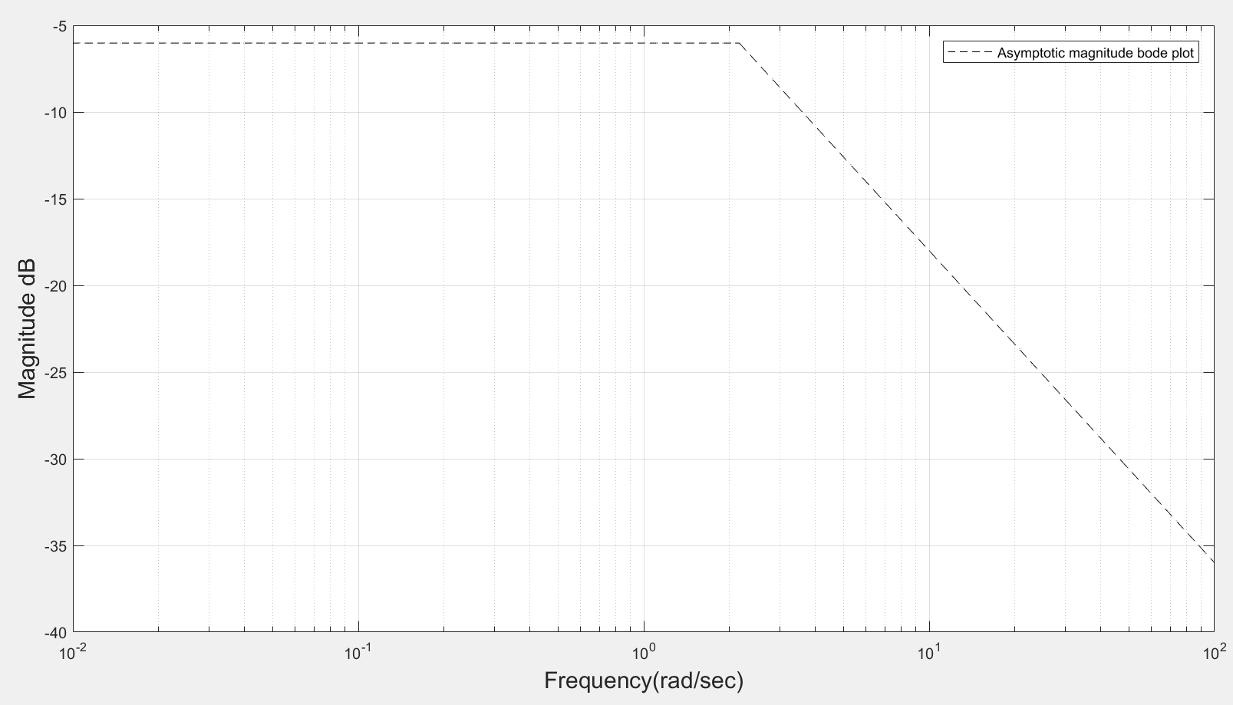

**Figure 3.5- Asymptotic magnitude bode plot of fractional pole.**

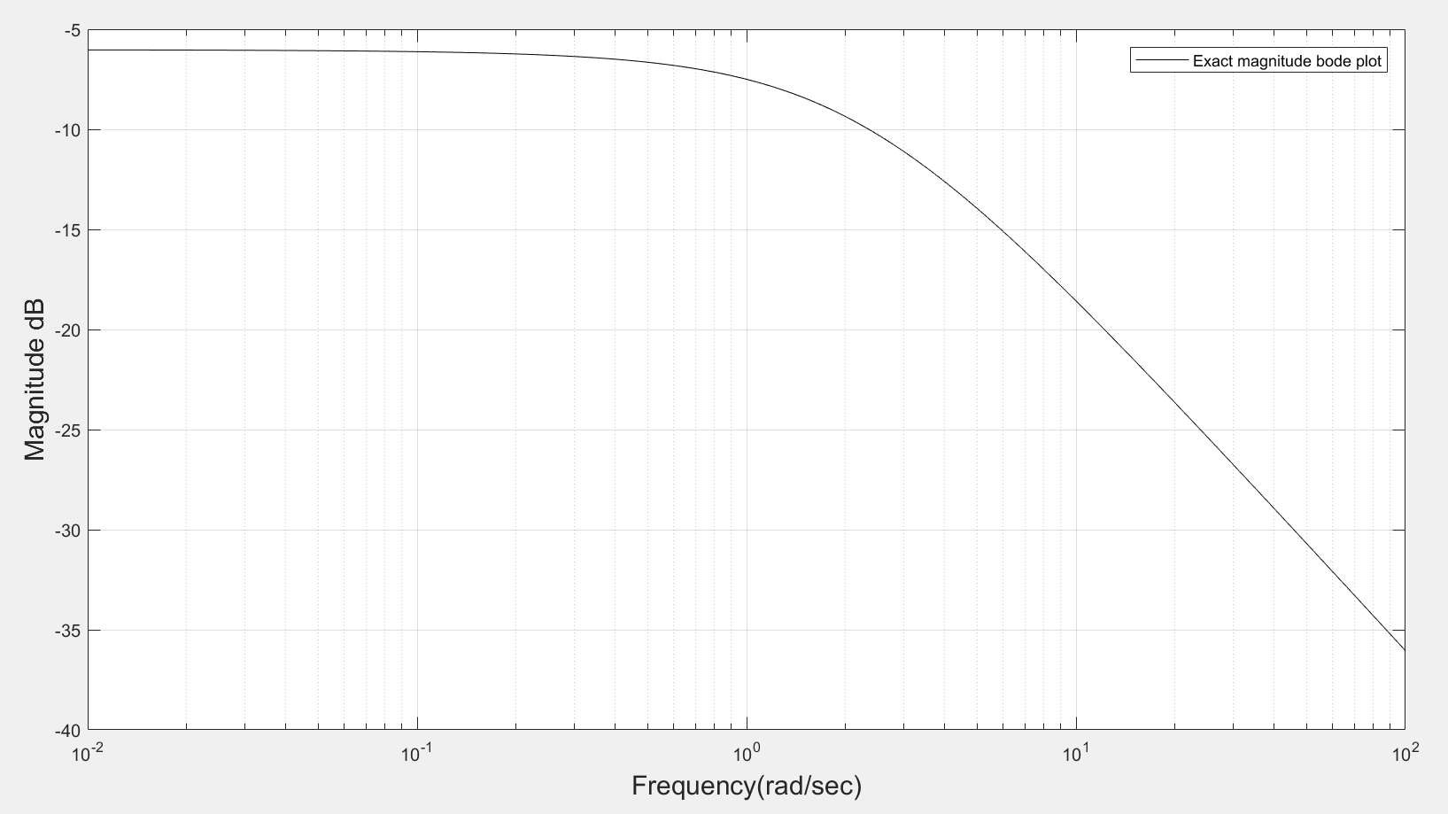

**Figure 3.6-Exact magnitude bode plot for fractional pole.**

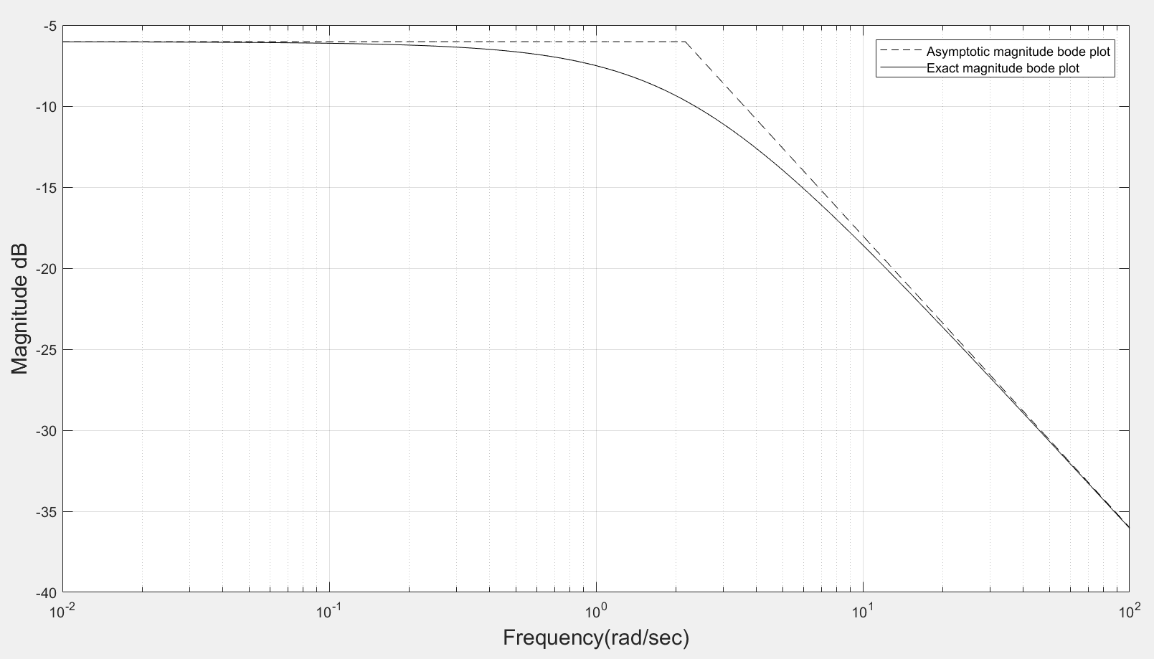

**Figure 3.7-Real and asymptotic bode plot for fractional pole.**